Thornhill Parent Update 16th February 2024
Last Friday, our school choir had the honour of representing Thornhill and the city of Sunderland at Durham Cathedral in the Northeast Choir of the Year. This is the first time our students have done this. They were not phased by the event, and sang beautifully, their performance was outstanding, we were really proud of them.
This afternoon, our Y11 students collected their mock GCSE exam results, in the same way as they will do in 6 months’ time. We wanted them to get the same experience of how it feels to collect and open their results on results day, experiencing the feelings of joy, and maybe disappointment that this experience can give, but with the knowledge that they still have at least 3 months to impact on their results for this summer. We are so proud of how they responded to their mock exams, and we know they will work with us from now until the summer to fine tune their performance in their GCSE’s.
At the end of Year 11’s GCSE exams, we will hold our school prom. To reduce the costs for families and the cost to the planet, we are hosting a Sustainable Fashion Prom Event in school. If you have any dresses, suits, bags or shoes to donate, we would love to give them a new life. Please contact school reception or Miss Mills, Head of Year 11.
Next week is half term, we return to school on Monday 26th February for the start of half term 4.

Mrs S Hamilton

Headteacher

During the half term break, 19th February to 23rd February the school office will be open 8:30am to 3:30pm

GCSE Preparation
Following our recent mock examinations for Year 11 pupils, I write to provide you with an update on results, and upcoming opportunities to support your child in their final preparation for the summer GCSEs.
- Mock Results
- A dedicated mock result assembly took place on Friday, 16th February. During this assembly, each pupil received their individual mock results, along with a detailed question level analysis in mathematics, allowing them to understand their strengths and areas for improvement. This personalised feedback will be invaluable in guiding their future revision. A copy of their results will also be sent home.

- Supporting your Child Parents’ Evening
Building on the insights from the mock results, we are hosting a ‘Supporting your child evening’ on 29th February 3.30-6.00pm. The evening is specifically designed for parents and carers to gain practical strategies for helping their child make the most of their mock results and prepare effectively for the summer exams. It will cover topics such as:

- understanding the mock results
- setting realistic and achievable goals
- future plans
- managing stress and exam anxiety

We strongly encourage you to attend this informative evening, which will equip you with the knowledge and tools you need to support your child during this crucial time.

Please remind your child to continue to use the resources available to them:

- Class charts: Subject teachers use this for revision materials.
- Period 6 study support: Dedicated time in school to work on revision, ask questions, and receive guidance from teachers.
- Revision sessions which will run during the half term break - see timetable below:

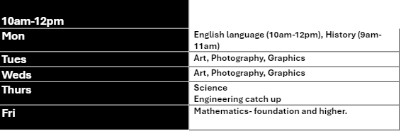

We appreciate your continued support and encouragement. By working together, we can ensure that your child feels confident and well prepared for his/her summer examinations.

Spotlight on Art and Design
It has been great to drop into art lessons this week to see the development of students creative ideas from different year groups. Here is just a selection of work ranging from year 7 to year 10. Well done art students!
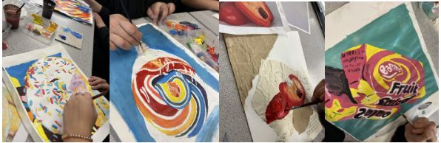

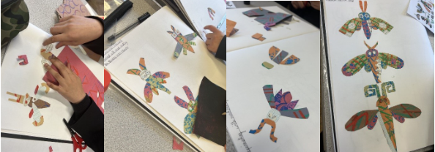


Assemblies
This week in assembly we have been raising awareness about Children's Mental Health Week.
The theme of Children's Mental Health Week 2024 was “My Voice Matters”. We encouraged children and young people to use their voices and share what matters to them.



Personal Development
Guidance Curriculum
Please see below for our guidance lesson themes from this week:

Year 7 LGBTQ+
Year 8 Homophobia
Year 9 Modern Slavery
Year 10 Sexual Violence
Year 11 Cosmetic Surgery

Parents can support their child’s learning in their Personal Development education by:
- Celebrating individual differences to promote a greater sense of belonging for everyone in society.
- Talking openly with your child to model confidence in discussing tricky topics.
- Listening to your child without judgement.
- Engaging with the school’s parent consultations about RSE topics.
  - Staying up to date with what is being taught, and when, so you can follow up on these topics at home.
- Asking for support if you need it - you are not expected to know everything!

Student Leaders
At Thornhill we are keen to develop students’ responsibility and independence and want to re-introduce our student leaders programme. We would like to invite students from all year groups to apply to become one of our new Literacy Leaders,
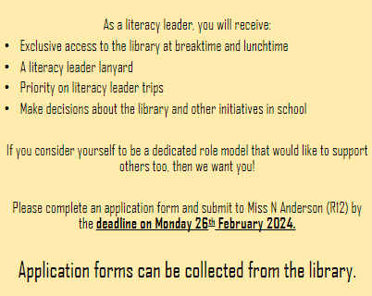
Look out for opportunities to join our Sports Leaders team too!

Co-Curricular
We are currently asking students for their feedback on our co-curricular clubs and activities. Please encourage your child to have their say and let us know what clubs, trips, and events they want to see at school.

 | Monday | Tuesday | Wednesday | Thursday | Friday
Lunch Time | Starfish Club | Careers Café  Handbell Club | Yav- Sports  Doorstop gigs (1) | Lunchtime Music | Doorstop gigs (2)  Charity Club
After School | Netball  Puzzle Club  Choir  Coding Club | Debate Club | Football  Star Wars  Crest Award  Cricket | Badminton  Hidden Histories  Further Maths  Drama | Ukulele Friday

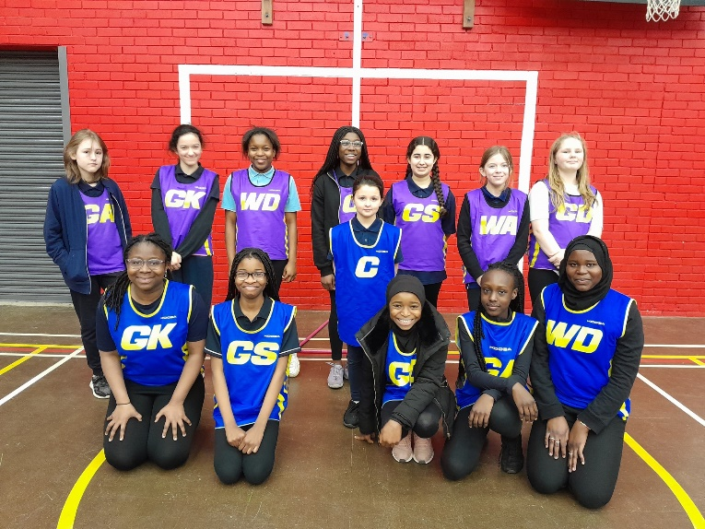
Netball
Well done to the Y7 and Y8 netball teams. They played two challenging matches and showed great strength and resilience in their performance. Great experience in preparation for the upcoming tournaments.


Competitions

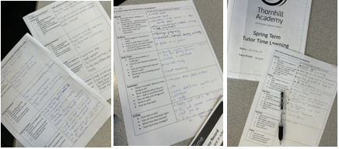
We have had our deadline for our whole school writing competition. Students have been working on this in their tutor time, as well as in their own time. It was great to check in on some of their great planning this week. We really look forward to submitting entries, sharing great stories, and issuing prizes next half term.
Good luck to all students!

Careers

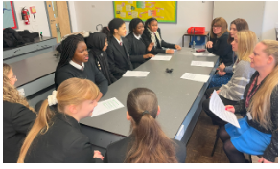
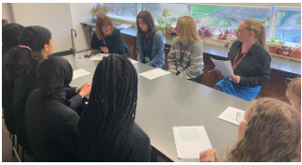
Last week was ‘International Day for Women’ and ‘Girls in Science’. Our amazing students took the opportunity to interview our amazing Science teachers about their experience working in the world of science. You can read about their discussion in our Blog Post below. Thank you to Mrs McIlwraith, Miss Boyd, Miss Harrison and Mrs Hamilton, along with Poppy, Tia, Hollie, Daniella, Treasure, Sawdah, Agatha and Dera.

Treasure: What inspired you to pursue a career in science
Miss Boyd: This career is not what I wanted to do originally, I liked science, and I did not think as far as jobs when I was at school, but I loved science, and learning about the human body and what your body does. But then I had a teacher who was really good, and he really inspired me to do more, especially in biology which is my favourite subject personally. I wanted to go on and do medicine, but then I thought I liked learning a little more than I like doing, so I wanted to do teaching instead, so I chose that as an option instead.

Dera: Why do you think we should encourage women and girls in science? And why does science need more women and girls?
Miss MciLwraith: I think women bring a new perspective into the field and that perhaps, men don’t always think of the same solutions, it is having that diversity and different thinking. Even in the classroom when we question, we always get different thought processes between males and females. I think it is all about, if you have that love of science, why shouldn’t you move it forward, and we see that in the classroom and how successful females can be, just the same as any males, and, I think, we just need to encourage that.

Sawdah: What are the challenges to you as a woman in science? What’s good about being a woman in science?
Miss Harrison: I think when I was in school, we never really had a huge conversation about gender attached to science, so my science department in school was very split. It was not until we looked at the disciplines, biology, chemistry and physics, that you then see a bit of gender attached. So I’m a physicist but in school I only had male physics teachers, so when I was picking my discipline as a teacher I was thinking should I be doing biology as I only saw biology teachers who were female, but then I thought, no my passion is physics that is what I want to do, it does not matter who I saw teaching me when I was at school, that is what I wanted to do, no one ever stopped me from doing it, so I did it.

Hollie: What one thing should we celebrate about women in science?
Mrs Hamilton: I think, going back to what Miss McILwraith said, the fact that, as females, we sometimes bring a different way of thinking to the world of science, and thinking differently can lead to a solution to something that was not there before. I also think what we should celebrate, the fact that gender isn’t an issue, but gender was an issue. I think one of the things we can look back on is when we look at famous scientists, we see lot of male scientists, but if we were to look at the most recent generation, we will see that the balance is becoming more even, it’s definitely not where it needs to be, but it’s really about the celebration of women in science pushing forward and saying this is what everybody can do , everybody has those opportunities. What I think is important in school is that we have a balance of male and female teachers so that, just as Miss Harrison said, when she was at school having a male biology teacher did not happen, we need to have a spread of teachers so we see science as being something that, if you are passionate about you are absolutely going to move forward with.

Miss McILwraith: If we look recently, Dame Sarah Gilbert, she works in Oxford and she was the female lead scientist for the Covid Vaccine. So even really recently there is a role model for all girls to look at, I mean you could not celebrate and be more successful than that!
Daniella: What one priority action would you recommend to achieve gender equality?
Miss McILwraith: I think education around the world!

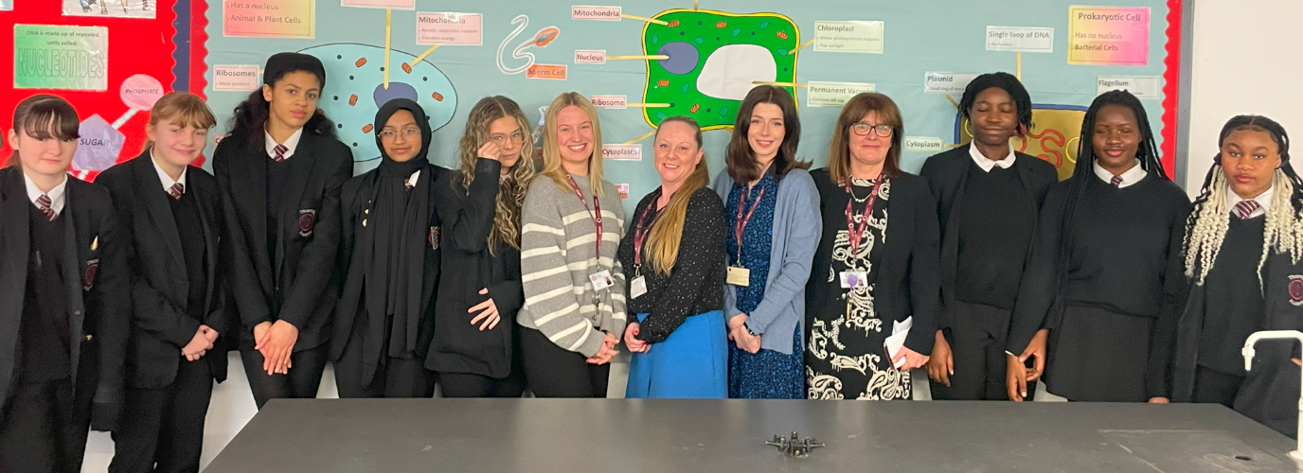

Northern Gas Networks Visit
This week, year 8 gained an extra science lesson from Northern Gas Networks all about our atmosphere and the impact on renewable and non-renewable energies. They learned about the work of NGN and our future in achieving NET ZERO! Thank you to NGN, and to year 8 for engaging so well.

M10 Boys Network
Our Boys Network had their first session after school this week where they met their mentors from a range of businesses, including J P Morgan, Arriva, Northumbrian Water, Proctor and Gamble, and many more. The boys did us proud in the way they maturely engaged in conversation with their mentors and got to know one another. This session was all about self-awareness and identifying their strengths, and what opportunities they have taken to contribute to their personal growth.

After our first session, this is what our boys had to say...

“It was good, for the first time meeting them it wasn't awkward, it was good.”
“I thought it was going to be a lot more stressful but it wasn't, it was much more chillaxed!”
“They are going to help me, like how to get a job, to get the things I want.”
“They talked about their experiences; they gave good advice.”
“They were really kind in what they said.”
“My mentor was inspiring; he's done lots of things... maybe I'll be like him.”
“I am looking forward to another one, I liked how they helped me identify my weaknesses, but also show how
to improve on them.”
Well done to Callum H, Syed M, Abdullah M, Jake S, Lewis C, Daniel J, Paul S and Bradley C.

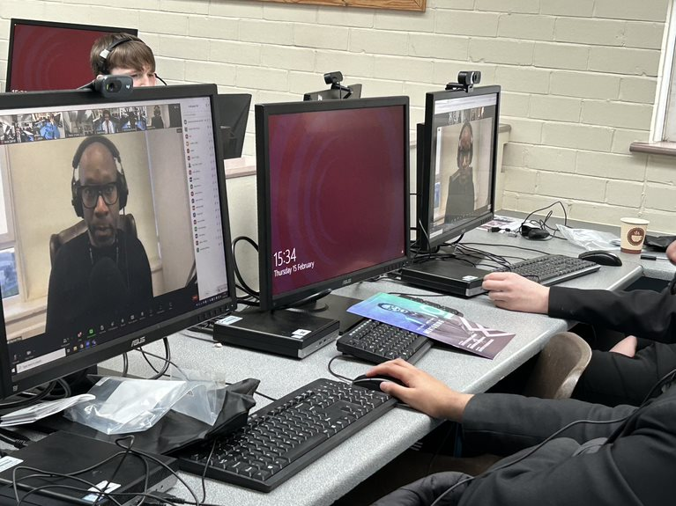
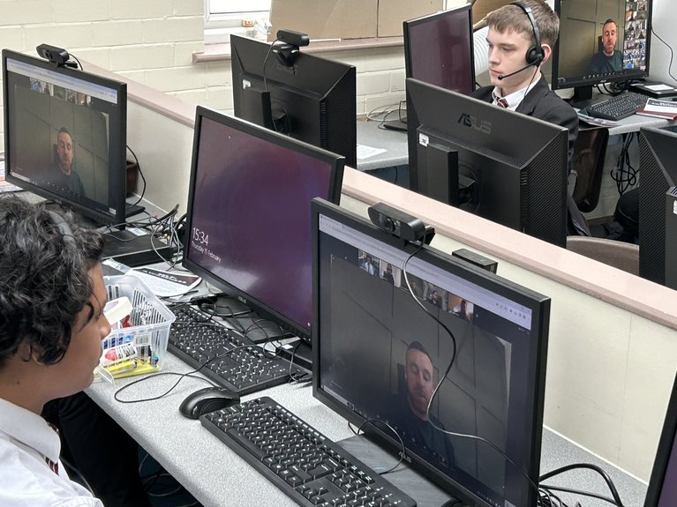

We are looking forward to numerous events coming soon:

Next half term
Year 7 and 9 Navy Teambuilding – 6th March
Year7 STEM event - 18th March
Year 8 STEM event - 13th March
Year 8 Safety works trip – 25th March
ALL Inspiration Day – 12TH March
ALL Young Enterprise
ALL Financial Awareness Week
ALL Make Your Mark – Youth Parliament Voting

ParentPay App
Student Information – PLEASE UPDATE NOW
It is important that we have up to date information on your child. This includes correct address and telephone numbers, emergency contact details, medical updates, including allergies, etc.

Much of this can be updated by parents/carers through the ParentApp. Please log into ParentApp and check that all the information that we hold for your child is correct and update where necessary.

If you are unable to access ParentApp, please contact the main school office who will be happy to assist by making the changes and helping you set up ParentApp for future use.

Free School Meals
Please see the school details for information around Free School Meal entitlement. If you are not currently entitled to receive Free School Meals, complete the form and if, in the future, circumstances change, the entitlement could automatically start for your child.

Lunch Accounts
We are currently looking at all student lunch accounts and will be contacting parents/carers where there is significant debt on a student’s account. We will no longer be able to provide meals for those students who have considerable debt on their accounts and who make no payment to reduce the balance.
Please clear any overdrawn balance now or contact the main school office if this will cause undue financial burden.

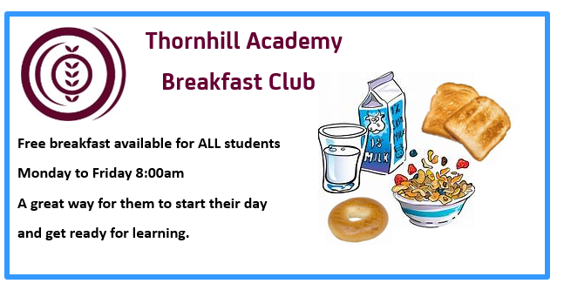
Breakfast Club
Your child is also entitled to attend our free daily breakfast club.
A reminder that the daily School Breakfast Club starts at 8.00 am each school day. Students will not be able to access the club before 8.00am

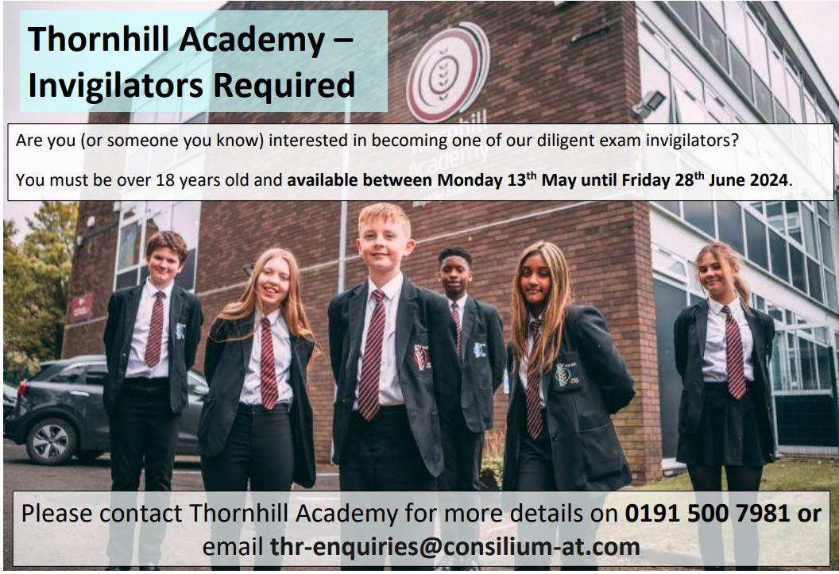

Sharp Reporting System

Were you aware Thornhill has a web based anonymous reporting function? This is the direct link to the reporting feature, but this can also be accessed through the school website: https://thornhill.thesharpsystem.com/

Standards and Expectations
Uniform and Equipment
As the temperature has now dropped, please can we remind students of our uniform expectations, standards need to be maintained in all weather. Students must wear a Black V Neck Jumper underneath their blazer each day. If additional layers are required, then this needs to be a dark waterproof coat which is worn over the blazer. There should be no additional layers beneath the blazer. Tracksuit tops and Gillet style jackets are not permitted and will be confiscated if worn. Also, a reminder that trainers or converse style shoes are not permitted.

Students are required to bring their bag to school each day, along with their planner and pencil case with equipment. Please can you check that your child is fully equipped for school each day, ready to learn.

A massive thank you to parents for their support in ensuring students have full uniform, including a jumper, bag, equipment, and planner. If students have misplaced their planner, they can be purchased via the main office and money is payable via Parent Pay for £4. Other stationary items can also be purchased in the same way, 25p per item or £1.50 for the pencil case with all equipment.

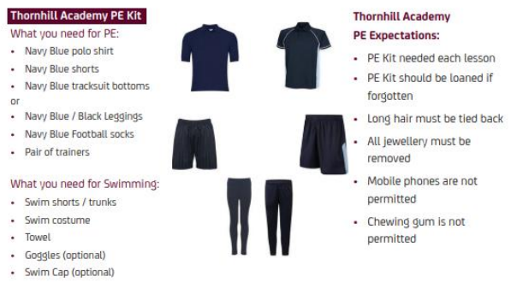

Class Charts - PLEASE LOGIN

Please can we ask you to ensure that as a parent you have downloaded the app or access class charts via the browser https://www.classcharts.com/parent/login to login.

Class charts is the main method of communication between staff, parents and pupils. If you do not have these details or need your password resetting, please contact school and we can give you this over the phone or alternatively email thr-enquiries@consilium-at.com

Behaviour Policy
The behaviour policy has been reviewed, and there are changes which will be implemented to ensure there is a clear escalation process which is explicit to students. After school, detentions will replace the RJC system that we have at present. The staged response is outlined in the table below. When a child reaches a C4, they will be given a same day 30-minute detention notification, this will be via class charts. If a child has two C4 behaviours in one day, they will be placed in Reflection for the remainder of the day and the same day, detention will be extended to 45 minutes. Parents will receive a second detention notification where this is the case. As detentions are on the same day, it is essential that all parents have access to class charts to ensure you receive these notifications.

If a child fails to engage, or fails to attend the detention, then there will be an escalation process and the detention will be extended. The next stage will be implemented the following day in school.

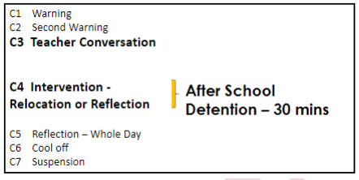

Lates
Good punctuality at school is essential for students to achieve their full educational potential. It is also vital for students to form good habits for later life. Pupils need to attend school regularly to benefit from their education. Missing out on learning, leaves children vulnerable to falling behind. Where students are persistently late, this will impact on the progress that students make in school. We do appreciate that there may be an occasion where a child is late for school with a genuine reason for lateness, however, where this is a recurring issue, a detention will be issued. If a child has three late marks in a half term, they are persistently late to school. When a student reaches three late marks in a half term, they will be issued a same day 30 minute after school detention. This detention is compulsory and will escalate if the student does not attend. This is a deterrent to help improve punctuality and reduce lost learning time.

Please can we remind all parents that we request students to be on site for 8.30am each day, classes start at 8.40am prompt.

We would like to thank you in advance with your support on this matter.

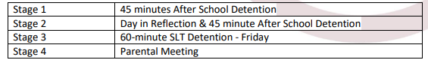

Trips and visits
Details of our existing trips can be found by clicking on the links below:

Geography Trip
Derwent Hill Trip details
Wicked
Wicked Theatre Trip details

Alumni Network
If you are a former pupil, we want to hear from you!

Thank you for the overwhelming support we always receive from parents.
We are extremely proud of our Alumni. When our students leave following completion of their GCSEs, they progress on to some incredibly exciting and far-reaching pathways.

What is it?
The Consilium Alumni will be a network of former students across all Consilium Academies.

The Alumni programme aims to:
- Allow continued support where needed for our former pupils
- Create a network of former pupils who are now in further education or employment, who may be able to use this experience to inspire and support current students
- Celebrate the achievements of former pupils
- Advertise local jobs which may appeal to former students and their families

Who can join?
Any former student or staff member from one of our Consilium Academies schools.

Join our network today and help us continue to build our Consilium community!
Sign up here

Parent Information
Get in touch
- At Thornhill Academy we understand the importance of sharing information and news with our parents and carers. Each week we publish our Parental Bulletin to ensure you are kept up to date with recent school news.
- We also want to hear from you! We love to share good news stories and the amazing accomplishments made by our pupils.
- If you have some good news to share about your child, please get in touch via email:
- thr-enquiries@consilium-at.com
- Follow us
- Don’t forget to follow us on social media for the latest updates on school activities

Twitter@thornhill_uk
Instagram@thornhill_academy
FacebookThornhill Academy

To view all Parents Letters please click the link below:
View Parents Letters

Out of School Activities
Sunderland Vikings Handball Sessions

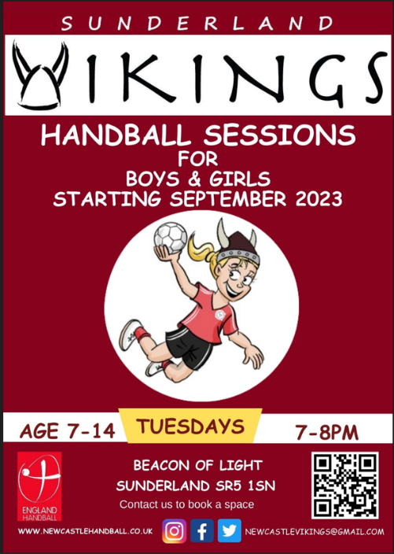

Come and join us in our fun, friendly and inclusive handball sessions for girls and boys (age 7-14) at Beacon of Light on Tuesdays from 7-8pm.
The children will get a taste of what handball is by playing small sided fun passing games, shooting at goals, and playing mini matches.
Two free taster sessions. After this, it is a cost of £6 per session. All children signing up as members get a free Sunderland Vikings Handball t-shirt.
To sign up please email newcastlevikings@gmail.com


Half term Activities:
Book now at: https://www.exposunderland.com/programme

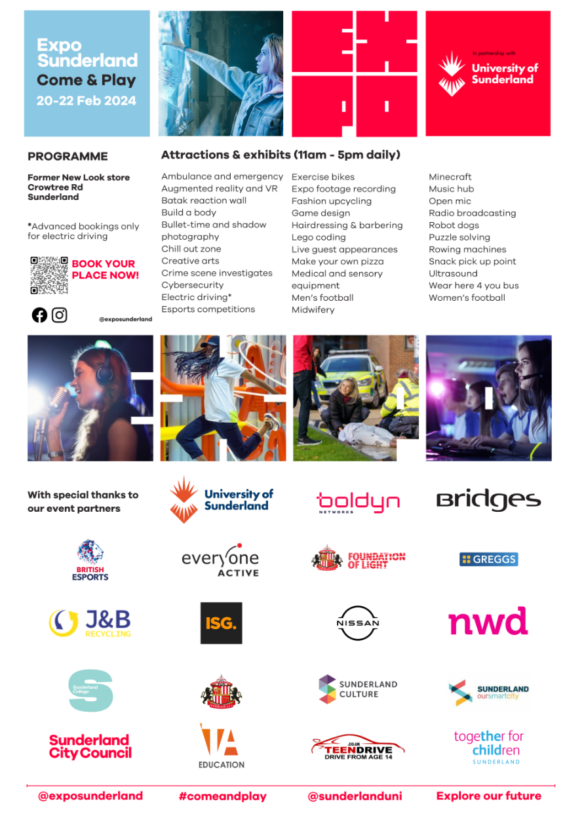

Government Advice
Back to School advice - UKHSA
UKHSA reminds parents of back-to-school advice - GOV.UK (www.gov.uk)

