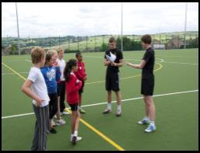
Title of Newspaper
Name

What it takes to be a successful Sports Leader
SKILLS

Support Box

Use this support box with your notes and the powerpoint to help you write this article.

Introduction
A Sports Leader is ….
A Successful Sports Leader is someone who… (list general skills, qualities and responsibilities)

Paragraph 1 Communication
Describe the different types (verbal / Non Verbal) Why are they important?
Give a sporting example.

Paragraph 2 Organisation
Talk about equipment, size of the group, area you are working in.
Give an example from sport.

Paragraph 3
Target Setting
Describe how a sports leader might use target setting to improve performance. Give an example.

Paragraph 4
Knowledge
Discuss why it is important to have good knowledge of sport and what would happen if you didn't have it.

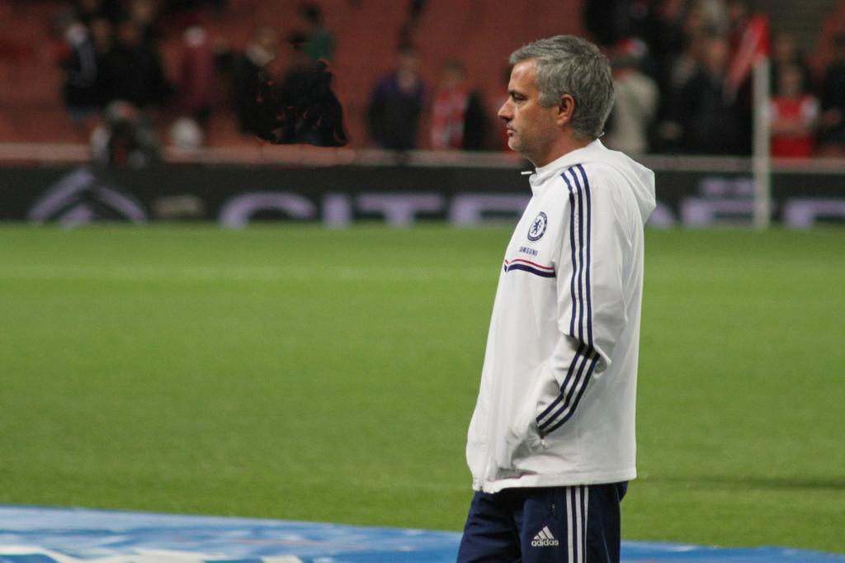
What it takes to be a successful Sports Leader
ATTRIBUTES

Support Box

Introduction
Identify the different qualities a successful sports leader should possess.
A successful sports leader should have the following attributes……

Paragraph 1
Appearance
Discuss why this is important and give an example from sport.

Paragraph 2
Enthusiasm
Why is it important to be enthusiastic when delivering sport?

Paragraph 3
Confidence
A sports leader should be confident because….

Paragraph 4
Leadership Style
Talk about the 3 different styles and the advantages and disadvantages of each.

Paragraph 5
Motivation
Key words Intrinsic, extrinsic

Paragraph 6
Humour / personality
Having a good personality helps you create a positive relationship with….

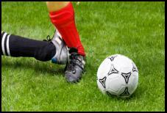
What it takes to be a successful Sports Leader
Responsibilities

Support Box

Paragraph 1 Professional Conduct
Talk about use of language and being a good role model.
Why is this important?

Paragraph 2
Health & Safety
It is important to consider Health and Safety because….
Key words; Equipment, following rules, risk assessment.

Paragraph 3
Equality
Treating all participants with respect is important because ….

Paragraph 4
Child Protection
Talk about child safety and police checks.

Paragraph 5
Ethics and Values
Key words
High expectations
Building trust
Staying professional

Comparing and Contrasting 2 Sports Leaders
KEY WORDS
Skills – Knowledge, Structuring Activities, Communication, Target Setting, Organisation of Equipment. Attributes – Leadership style, Enthusiasm, Humour, Appearance, Motivation, Personality, Confidence. Responsibilities - Health & Safety, Ethics and Values, Professional conduct, Insurance, rules and regulations, equality.

In this section discuss the skills, attributes and responsibilities that are similar between two sports leaders. For each point you make, say why it is important in their role and how this then affects the participants the lead.

Similarities

In the section talk about each leader and explain how they are different. Also mention the IMPACT this has on the pupils.

Differences

